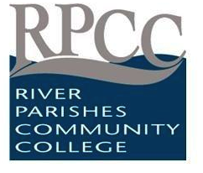
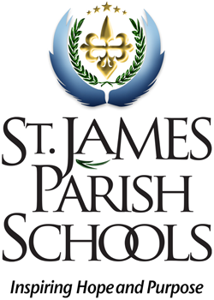
Early College High School Partnership
St. James Parish Public School District &
River Parishes Community College

St. James Parish Public School District, in partnership with River Parishes Community College, is expanding its dual enrollment program for both advanced and career & technical course offerings. Since 2006 dual students in St. James high schools are introduced to technical courses and college level courses prior to enrolling full time at a post secondary school. These state approved courses are transferable to respective state public technical colleges, community colleges and universities upon graduation from high school and enable students to complete certifications, licensures and/or college degrees in fewer semesters. These courses can be offered on St. James school campuses or RPCC campus at no cost to the student. Selected courses taught in the District’s Career & Technical Center will be open to RPCC students & partner Districts.

RPCC promotes strong partnerships in the River Parishes Region improving opportunities for high school students to receive an excellent post-secondary education and to complete training for entry directly into the workforce. The partnership with St. James Parish schools for dual enrollment and the Early College is increasing the number of high school students earning college credit and providing the training students need to succeed in the work place.

The Early College is an innovative approach that gives students a jump start on a four-year degree. Now a student can earn a transferable associate degree, while still in high school.

